]]

ICT AND ITS IMPACT ON MODERN SOCIETY
Raw File

Submitted To:
Adnan Jelani
Submitted By:
Muhammad Ibrahim Siddiqui
Reg Number: DATE:
260401092 26/10/2026

Introduction
I
nformation and Communication Technology, often referred to as ICT, is one of the most significant forces shaping the modern world. It encompasses the integration of computing, telecommunications, and information processing to enable people to connect, share, and create knowledge. ICT is not a single invention or tool but rather a combination of many evolving technologies that continue to transform society.

The Growth of ICT

Early Developments
The story of ICT begins with early computing machines and simple telecommunication devices. Over time, these technologies merged to create powerful systems that allow humans to process vast amounts of data and communicate instantly across the globe.

The Role of the Internet
The development of the internet, mobile devices, and cloud computing has accelerated this growth. Today, billions of people use ICT daily, and it is difficult to imagine life without it.
[Insert Citation Here – Example: Smith, 2022]

ICT in Education

Digital Classrooms
In the field of education, ICT has revolutionized both teaching and learning. Classrooms are no longer confined to four walls and chalkboards. Teachers now use interactive whiteboards, digital projectors, and learning management systems to share lessons.

Online Learning
Students access online libraries, take part in virtual classrooms, and collaborate with peers through digital platforms. During the global pandemic, ICT became even more essential, as millions of students relied on video conferencing and online resources to continue their studies. (Johnson, 2023)
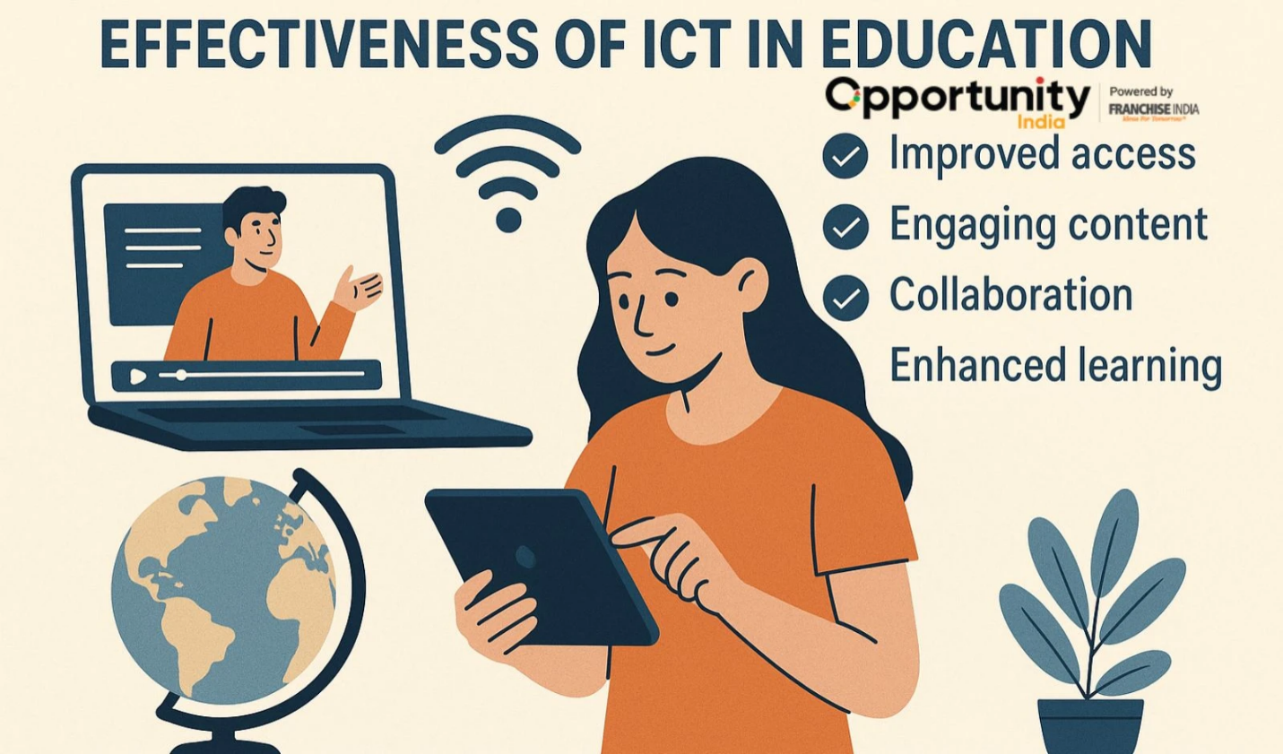

1- ICT in Education

ICT in Healthcare

Electronic Records
Healthcare has also benefited greatly from ICT. Doctors and nurses rely on electronic health records to manage patient information efficiently.

Telemedicine and Mobile Health
Telemedicine has created opportunities for patients in remote areas to consult specialists without traveling long distances. Mobile health apps now help people track their fitness, monitor chronic conditions, and receive reminders for medication.

Figure 2 ICT Healthcare

ICT in Business and Commerce

E-Commerce
Business is another area where ICT plays a central role. Companies use ICT to manage supply chains, conduct online marketing campaigns, and process financial transactions. E-commerce platforms allow small businesses to reach global markets.

Data and Communication
Large corporations rely on complex data analysis to make strategic decisions. Communication tools such as video conferencing, instant messaging, and collaborative platforms reduce the need for physical meetings and speed up workflows.

Sector | Benefits | Example Application
Education | Access to online resources, digital collaboration, flexible learning | Virtual classrooms, e-libraries
Healthcare | Improved patient records, remote consultations, better diagnostics | Telemedicine, electronic health records
Business | Faster communication, global markets, data-driven decisions | E-commerce platforms, video conferencing
Daily Life | Convenience, connectivity, entertainment, automation | Social media, smart homes, online banking
Table 1 Benefits of ICT Across Sectors

(Smith, 2022)

ICT and Daily Life

Everyday Tools
Beyond formal settings, ICT affects our everyday lives. Social media platforms connect friends and families across continents. Smartphones are now digital assistants, navigation tools, entertainment centers, and cameras all in one.

Smart Homes and Entertainment
Online banking enables people to transfer money instantly, while smart home devices allow remote control of lights, appliances, and security systems. Entertainment industries rely heavily on ICT, from streaming services to video games.
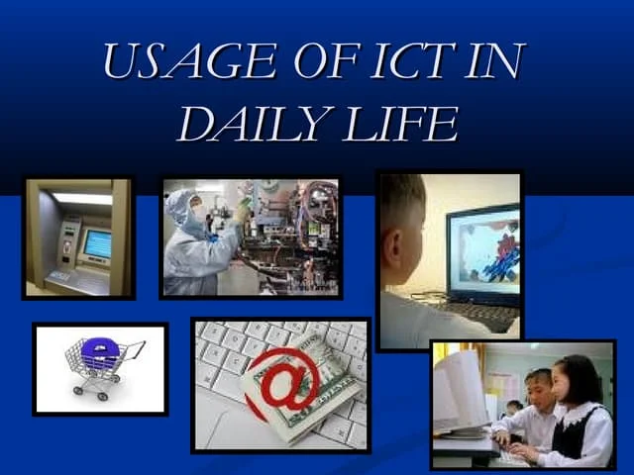
Figure 3 ICT In Daily Life

Challenges of ICT

Security and Privacy
Despite its many benefits, ICT introduces serious challenges. Cybersecurity is a growing concern, as hackers and cybercriminals exploit digital systems.

Ethical Issues
Ethical concerns such as plagiarism, intellectual property theft, and online harassment further complicate the picture.

The Digital Divide
The digital divide—unequal access to technology—remains a major issue, with rural and underdeveloped areas often left behind.

The Future of ICT

Artificial Intelligence
Looking ahead, ICT will continue to evolve rapidly. Artificial intelligence, machine learning, and robotics are already reshaping industries.

Robotics in Industry
Robotics is changing manufacturing and healthcare, where machines can perform repetitive tasks faster and more accurately than humans.

Emerging Technologies
The rise of 5G technology will provide faster and more reliable connectivity, supporting innovations such as smart cities and autonomous vehicles. Virtual reality and augmented reality will expand opportunities in gaming, education, and professional training.
(Johnson, 2023)

Conclusion
Information and Communication Technology is more than just a collection of gadgets. It is a force that transforms societies, economies, and cultures. From classrooms to hospitals, from offices to living rooms, ICT touches nearly every aspect of human activity. By learning how to use ICT effectively and responsibly, individuals can take advantage of its benefits while minimizing its risks.

Bibliography
Johnson, A. (2023). Introduction to digital tools. London: EduPublish.
Smith, J. (2022). ICT Basic Titles. New York: TechPress.

Citation data
Author | Year | Title | Publisher Location | Publisher
Smith, J. | 2022 | ICT Basics | New York | TechPress
Johnson, A. | 2023 | Introduction to Digital Tools | London | EduPublish

